实验（4）—— 类与对象

学生姓名：黄伟杰 专业班级：计算机211
课程名称：面向对象程序设计 实验类型：综合

一 实验目的
练习C++类与对象。

二 实验环境
PC机 + Windows 10操作系统 + CodeBlocks 集成开发环境

三 实验内容
1，声明并实现一个Triangle类，有成员变量三条边、周长和面积，成员函数Getarea()， Getlength()。实现重载的构造函数、拷贝构造函数、析构函数，并在main()中测试该类。
#include <iostream>
#include <cmath>
using namespace std;
class Triangle {
public:
Triangle();
Triangle(double _x, double _y, double _z);
Triangle(const Triangle &t);
~Triangle();
double GetArea();
double GetLength();
private:
double x, y, z;
double area, len;
};
Triangle::Triangle() {
x = 1; y = 1; z = 1;
len = x + y + z;
double p = len / 2.0;
area = sqrt(p * (p - x) * (p - y) * (p - z));
}
Triangle::Triangle(double _x, double _y, double _z) {
x = _x; y = _y; z = _z;
len = x + y + z;
double p = len / 2.0;
area = sqrt(p * (p - x) * (p - y) * (p - z));
}
Triangle::Triangle(const Triangle &t) {
x = t.x; y = t.y; z = t.z;
area = t.area; len = t.len;
}
Triangle::~Triangle() {

}
double Triangle::GetArea() {
printf("area = %.2lf len = %.2lf\n\n", area, len);
return area;
}
double Triangle::GetLength() {
printf("x = %.2lf y = %.2lf z = %.2lf\n", x, y, z);
return len;
}
int main() {
Triangle t1;
t1.GetLength(); t1.GetArea();
Triangle t2(1, 1, 1);
t2.GetLength(); t2.GetArea();
Triangle t3(6, 8, 10);
t3.GetLength(); t3.GetArea();
return 0;
}
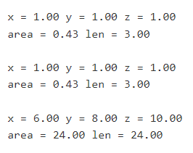
2，声明并实现一个Circle类，有成员变量radius（半径）、成员函数Getarea()。（要求实现重载的构造函数、拷贝构造函数、析构函数，并在main()中测试该类）
#include <iostream>
using namespace std;
const double PI = 3.14;
class Circle {
public:
Circle();
Circle(double _radius);
Circle(const Circle &t);
~Circle();
void GetArea();
private:
double radius;
};
Circle::Circle() {
radius = 1.0;
}
Circle::Circle(double _radius) {
radius = _radius;
}
Circle::Circle(const Circle &t) {
radius = t.radius;
}
Circle::~Circle() {

}
void Circle::GetArea() {
printf("radius = %.2lf area = %.2lf\n\n", radius, PI * radius * radius);
}
int main() {
Circle t1;
t1.GetArea();
Circle t2(2);
t2.GetArea();
Circle t(5);
Circle t3(t);
t3.GetArea();
return 0;
}
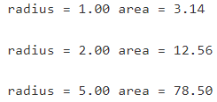
3，一圆形游泳池如图所示，现在需在其周围建一圆形过道，并在其四周围上栅栏。栅栏价格为35元/米，过道造价为20元/平方米。过道宽度为3米，游泳池半径由键盘输入。要求编程计算并输出过道和栅栏的造价。设计一个圆环类来解决该问题。
#include <iostream>
using namespace std;
const int FenceCost = 35, WayCost = 20, WayWide = 3;
const double PI = 3.14;
class Ring {
public:
Ring();
Ring(double _radius);
Ring(const Ring &t);
~Ring();
void GetPrice();
private:
double radius;
double fence, way;
};
Ring::Ring() {
radius = 1;
fence = 2 * PI * (2 * radius + WayWide) * FenceCost;
way = PI * ((radius + WayWide) * (radius + WayWide) - radius * radius);
}
Ring::Ring(double _radius) {
radius = _radius;
fence = 2 * PI * (2 * radius + WayWide) * FenceCost;
way = PI * ((radius + WayWide) * (radius + WayWide) - radius * radius);
}
Ring::Ring(const Ring &t) {
radius = t.radius;
fence = t.fence;
way = t.way;
}
Ring::~Ring() {

}
void Ring::GetPrice() {
printf("r = %.2lf FenceCost = %.2lf WayCost = %2lf\n\n", radius, fence, way);
}
int main() {
Ring t1;
t1.GetPrice();
Ring t2(2);
t2.GetPrice();
Ring t(5);
Ring t3(t);
t3.GetPrice();
return 0;
}
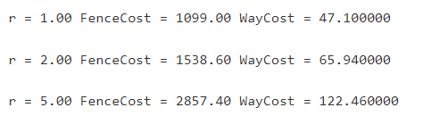
4，声明并实现一个复数类，使以下代码能够工作
Complex c1(1,2);
Complex c2;
Complex c3(c1);
c3.add(c1);
c3.show();
#include <iostream>
using namespace std;
class Complex {
public:
Complex();
Complex(int _f, int _s);
Complex(const Complex &t);
~Complex();
void Add(Complex t);
void Show();
private:
int f, s;
};
Complex::Complex() {
f = 0;
s = 0;
}
Complex::Complex(int _f, int _s) {
f = _f;
s = _s;
}
Complex::Complex(const Complex &t) {
f = t.f;
s = t.s;
}
Complex::~Complex() {

}
void Complex::Add(Complex t) {
printf("(%d+%di)+(%d+%di)=", f, s, t.f, t.s);
f += t.f;
s += t.s;
printf("(%d+%di)\n", f, s);
}
void Complex::Show() {
if (s >= 0) printf("%d+%di\n", f, s);
else printf("%d%di\n", f, s);
}
int main() {
Complex t1;
t1.Show();
Complex t2(1, -2);
t2.Show();
Complex t(3, 4);
Complex t3(t);
t3.Show();
t3.Add(t1);
t3.Show();
return 0;
}
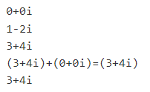
5，声明并实现一个员工类，内有姓名、性别、年龄、部门、联系电话、工种等信息，实现重载的构造函数、拷贝构造函数、析构函数和相关的接口,并在main()中测试该类。
#include <iostream>
#include <cstring>
using namespace std;
class Person {
public:
Person();
Person(char *_name, char *_gender, char *_part, char *_tel, int _age);
Person(const Person &t);
~Person();
void Show();
private:
char name[20], gender[5], part[20], tel[20];
int age;
};
Person::Person() {
strcpy(name, "Mike");
strcpy(gender, "Boy");
strcpy(part, "1-1");
strcpy(tel, "123456789");
age = 18;
}
Person::Person(char *_name, char *_gender, char *_part, char *_tel, int _age) {
strcpy(name, _name);
strcpy(gender, _gender);
strcpy(part, _part);
strcpy(tel, _tel);
age = _age;
}
Person::Person(const Person &t) {
strcpy(name, t.name);
strcpy(gender, t.gender);
strcpy(part, t.part);
strcpy(tel, t.tel);
age = t.age;
}
Person::~Person() {

}
void Person::Show() {
printf("name = %s\n", name);
printf("age = %d\n", age);
printf("gender = %s\n", gender);
printf("part = %s\n", part);
printf("tel = %s\n\n", tel);
}
int main() {
Person t1;
t1.Show();
Person t2("Tony", "Boy", "1-2", "987654321", 20);
t2.Show();
Person t("Betty", "Girl", "1-3", "456987321", 17);
Person t3(t);
t3.Show();
return 0;
}
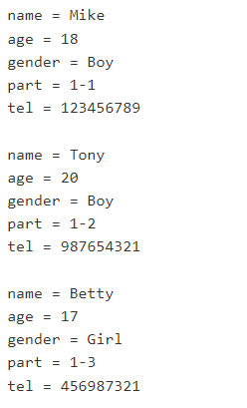
6，声明并实现一个整型数组类，内部封装一个整型数组(int a[10])，要求能顺序打印数组中的各个元素，统计各个元素之和、均值、最大值、最小值和中值,并在main()中测试该类。
#include <iostream>
using namespace std;
const int N = 10;
class Num {
public:
Num();
Num(int t[]);
Num(const Num &t);
~Num();
void Show();
private:
int arr[N];
int sum, max, min, mid;
double aver;
};
Num::Num() {
for (int i = 0; i < N; i ++) arr[i] = 0;
sum = 0; max = 0; min = 0; mid = 0; aver = 0;
}
Num::Num(int t[]) {
sum = 0;
for (int i = 0; i < N; i ++) {
arr[i] = t[i];
sum += arr[i];
if (!i || arr[i] > max) max = arr[i];
if (!i || arr[i] < min) min = arr[i];
}
mid = arr[4];
aver = sum / 10.0;
}
Num::Num(const Num &t) {
for (int i = 0; i < N; i ++) arr[i] = t.arr[i];
sum = t.sum; max = t.max; min = t.min; mid = t.mid; aver = t.aver;
}
Num::~Num() {

}
void Num::Show() {
printf("arr:");
for (int i = 0; i < N; i ++) printf("%d ", arr[i]);
printf("\nsum = %d max = %d min = %d\n", sum, max, min);
printf("mid = %d average = %.2lf\n\n", mid, aver);
}
int main() {
Num t1;
t1.Show();
int tarr[10] = {1, 2, 3, 4, 5, 6, 7, 8, 9, 10};
Num t2(tarr);
t2.Show();
Num t3(t2);
t3.Show();
return 0;
}
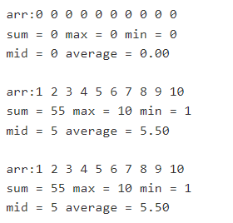
7，创建一个栈类，要求实现构造函数、判断栈是否为空、出栈、入栈等操作，通过数组来间接实现。
#include <iostream>
using namespace std;
const int N = 1e3 + 10;
class Stackk {
public:
Stackk();
Stackk(int _x);
~Stackk();
void Push(int _x);
void Pop();
void Show();
bool Empty();
private:
int arr[N];
int tt;
};
Stackk::Stackk() {
tt = 0;
}
Stackk::Stackk(int _x) {
tt = 0;
arr[tt ++] = _x;
}
Stackk::~Stackk() {

}
void Stackk::Push(int _x) {
arr[tt ++] = _x;
cout << arr[tt - 1] << " Pushed!" << endl;
}
void Stackk::Pop() {
tt --;
cout << arr[tt] << " Poped!" << endl;
}
void Stackk::Show() {
for (int i = 0; i < tt; i ++) cout << arr[i] << " ";
cout << endl;
}
bool Stackk::Empty() {
return tt > 0;
}
int main() {
Stackk s1;
for (int i = 1; i <= 3; i ++) s1.Push(i);
s1.Show();
if (!s1.Empty()) cout << "Stack is empty!" << endl;
else cout << "Stack is not empty!" << endl;
s1.Pop();
s1.Show();
Stackk s2;
for (int i = 1; i <= 2; i ++) s2.Push(i);
s2.Show();
s2.Pop(); s2.Pop();
if (!s2.Empty()) cout << "Stack is empty!" << endl;
else cout << "Stack is not empty!" << endl;
s2.Show();
return 0;
}
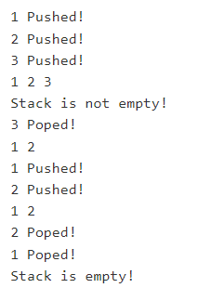
8，声明并实现一个矩形类，其属性为矩形的左下角与右上角两个点，并能计算矩形的面积。（先做Point类，再做矩形类，注意组合类的构造函数）
#include <iostream>
using namespace std;
class Point {
public:
Point();
Point(int _x, int _y);
Point(const Point &t);
~Point();
int GetX();
int GetY();
void InX(int _x);
void InY(int _y);
private:
int x, y;
};
Point::Point() {
x = 0; y = 0;
}
Point::Point(int _x, int _y) {
x = _x; y = _y;
}
Point::Point(const Point &t) {
x = t.x; y = t.y;
}
Point::~Point() {

}
int Point::GetX() {
return x;
}
int Point::GetY() {
return y;
}
void Point::InX(int _x) {
x = _x;
}
void Point::InY(int _y) {
y = _y;
}
class Rectangle {
public:
Rectangle();
Rectangle(Point _l_d, Point _r_u);
Rectangle(const Rectangle &t);
~Rectangle();
void Show();
private:
Point l_d, r_u;
int area;
};
Rectangle::Rectangle() {
Point t1, t2;
l_d.InX(t1.GetX()); l_d.InY(t1.GetY());
r_u.InX(t2.GetX()); r_u.InY(t2.GetY());
area = (r_u.GetX() - l_d.GetX()) * (r_u.GetY() - l_d.GetY());
}
Rectangle::Rectangle(Point _l_d, Point _r_u) {
l_d.InX(_l_d.GetX()); l_d.InY(_l_d.GetY());
r_u.InX(_r_u.GetX()); r_u.InY(_r_u.GetY());
area = (r_u.GetX() - l_d.GetX()) * (r_u.GetY() - l_d.GetY());
}
Rectangle::Rectangle(const Rectangle &t) {
l_d = t.l_d; r_u = t.r_u;
area = t.area;
}
Rectangle::~Rectangle() {

}
void Rectangle::Show() {
printf("(%d, %d)&(%d, %d)'s area: %d\n", l_d.GetX(), l_d.GetY(), r_u.GetX(), r_u.GetY(), area);
}
int main() {
Rectangle t1;
t1.Show();
Point p1(1, 2); Point p2(3, 4);
Rectangle t2(p1, p2);
t2.Show();
Point p3(5, 7), p4(9, 11);
Point p5(p3), p6(p4);
Rectangle t(p5, p6);
Rectangle t3(t);
t3.Show();
return 0;
}
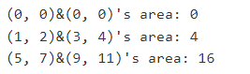
9，创建一个学生寝室类StuRoom，该类能表示寝室名、寝室电话、4个学生。该类中有构造函数、changeRoomName()、changeNum()函数能改变寝室的信息，display()函数把完整的寝室信息打印出来。（学生类有姓名、学号、学院、专业4个属性）
#include <iostream>
#include <cstring>
using namespace std;
class Student {
public:
Student();
Student(char *_name, char *_id, char *_aca, char *_major);
Student(const Student &t);
~Student();
void Edit(char *_name, char *_id, char *_aca, char *_major);
char name[20], id[20];
char aca[20], major[20];
};
Student::Student() {
strcpy(name, "Mike");
strcpy(id, "10001");
strcpy(aca, "1-1");
strcpy(major, "101");
}
Student::Student(char *_name, char *_id, char *_aca, char *_major) {
strcpy(name, _name);
strcpy(id, _id);
strcpy(aca, _aca);
strcpy(major, _major);
}
Student::Student(const Student &t) {
strcpy(name, t.name);
strcpy(id, t.id);
strcpy(aca, t.aca);
strcpy(major, t.major);
}
Student::~Student() {

}
void Student::Edit(char *_name, char *_id, char *_aca, char *_major) {
strcpy(name, _name);
strcpy(id, _id);
strcpy(aca, _aca);
strcpy(major, _major);
}
class StuRoom {
public:
StuRoom();
StuRoom(char *_name, char *_tel, Student _stu[]);
StuRoom(const StuRoom &t);
~StuRoom();
void ChangeName(char *_name);
void ChangeTel(char *_tel);
void Display();
private:
char name[20], tel[20];
Student stu[4];
};
StuRoom::StuRoom() {
strcpy(name, "101");
strcpy(tel, "101010101");
Student _stu[4];
for (int i = 0; i < 4; i ++) stu[i] = _stu[i];
}
StuRoom::StuRoom(char *_name, char *_tel, Student _stu[]) {
strcpy(name, _name);
strcpy(tel, _tel);
for (int i = 0; i < 4; i ++) stu[i] = _stu[i];
}
StuRoom::StuRoom(const StuRoom &t) {
strcpy(name, t.name);
strcpy(tel, t.tel);
for (int i = 0; i < 4; i ++) stu[i] = t.stu[i];
}
StuRoom::~StuRoom() {

}
void StuRoom::ChangeName(char *_name) {
strcpy(name, _name);
}
void StuRoom::ChangeTel(char *_tel) {
strcpy(tel, _tel);
}
void StuRoom::Display() {
printf("name:%s tel:%s\n", name, tel);
for (int i = 0; i < 4; i ++)
printf("stu[%d] | name:%s id:%s academic:%s major:%s\n", i + 1, stu[i].name, stu[i].id, stu[i].aca, stu[i].major);
}
int main() {
Student sarr[4];
sarr[0].Edit("Jack1", "10001", "1-1", "101");
sarr[1].Edit("Jack2", "10002", "1-2", "102");
sarr[2].Edit("Jack3", "10003", "1-3", "103");
sarr[3].Edit("Jack4", "10004", "1-4", "104");
StuRoom t("205", "13579", sarr);
t.Display();
t.ChangeName("309");
t.ChangeTel("2468X");
t.Display();
return 0;
}
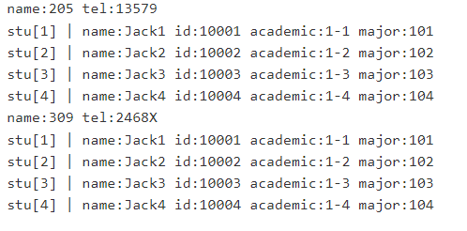
四 实验小结
巩固了C++的类与对象。

